Shepherd High School Madrigal 2014



I really enjoyed the SHS’ Madrigal Celebration last weekend. This was my first time attending, so I didn’t expect the live drama in the middle.

# Photo Gallery

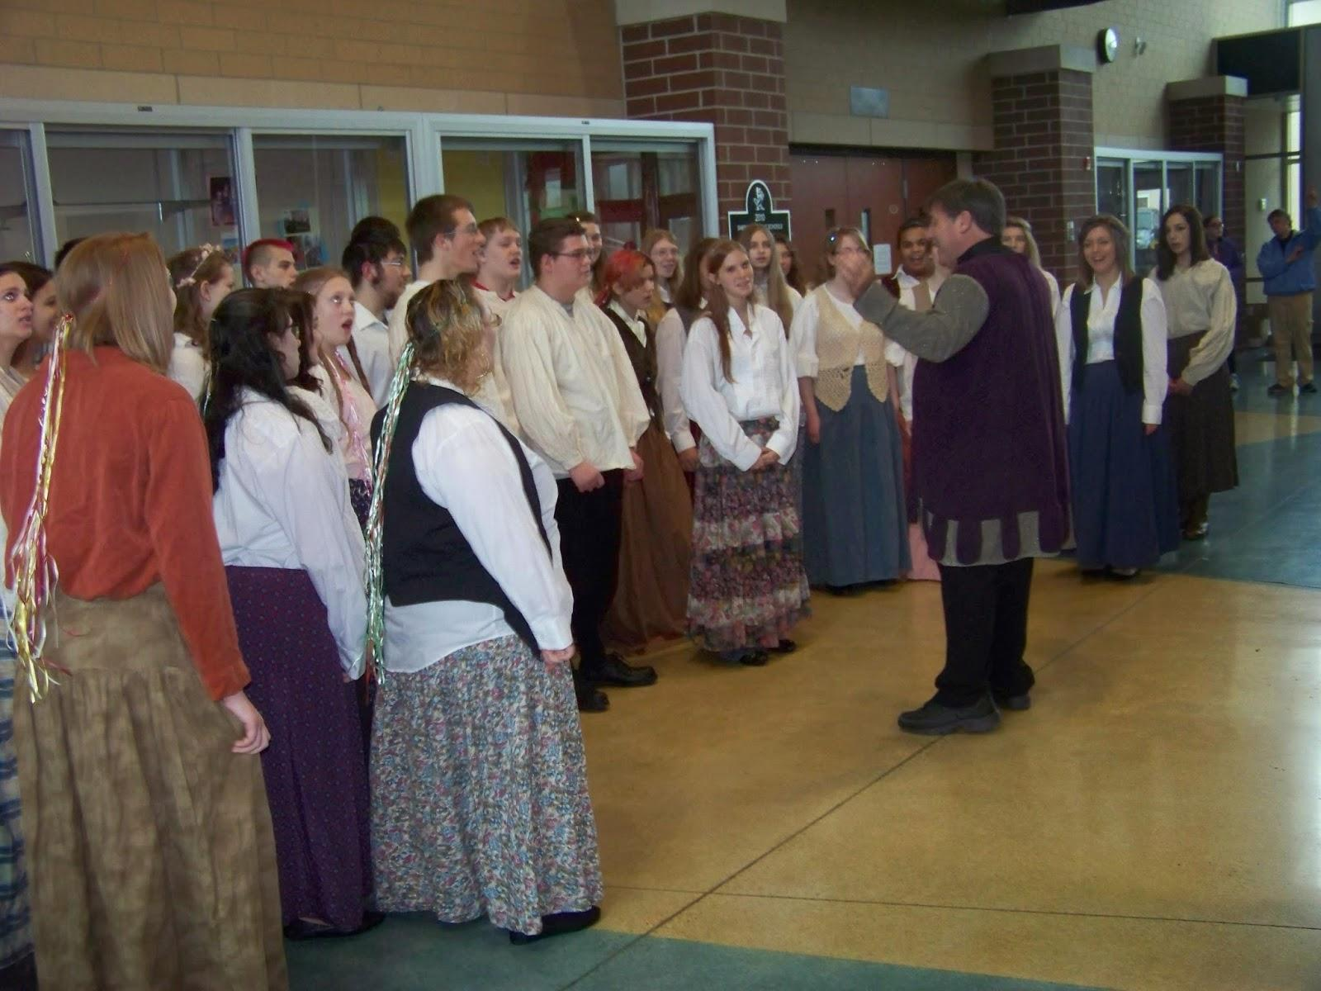

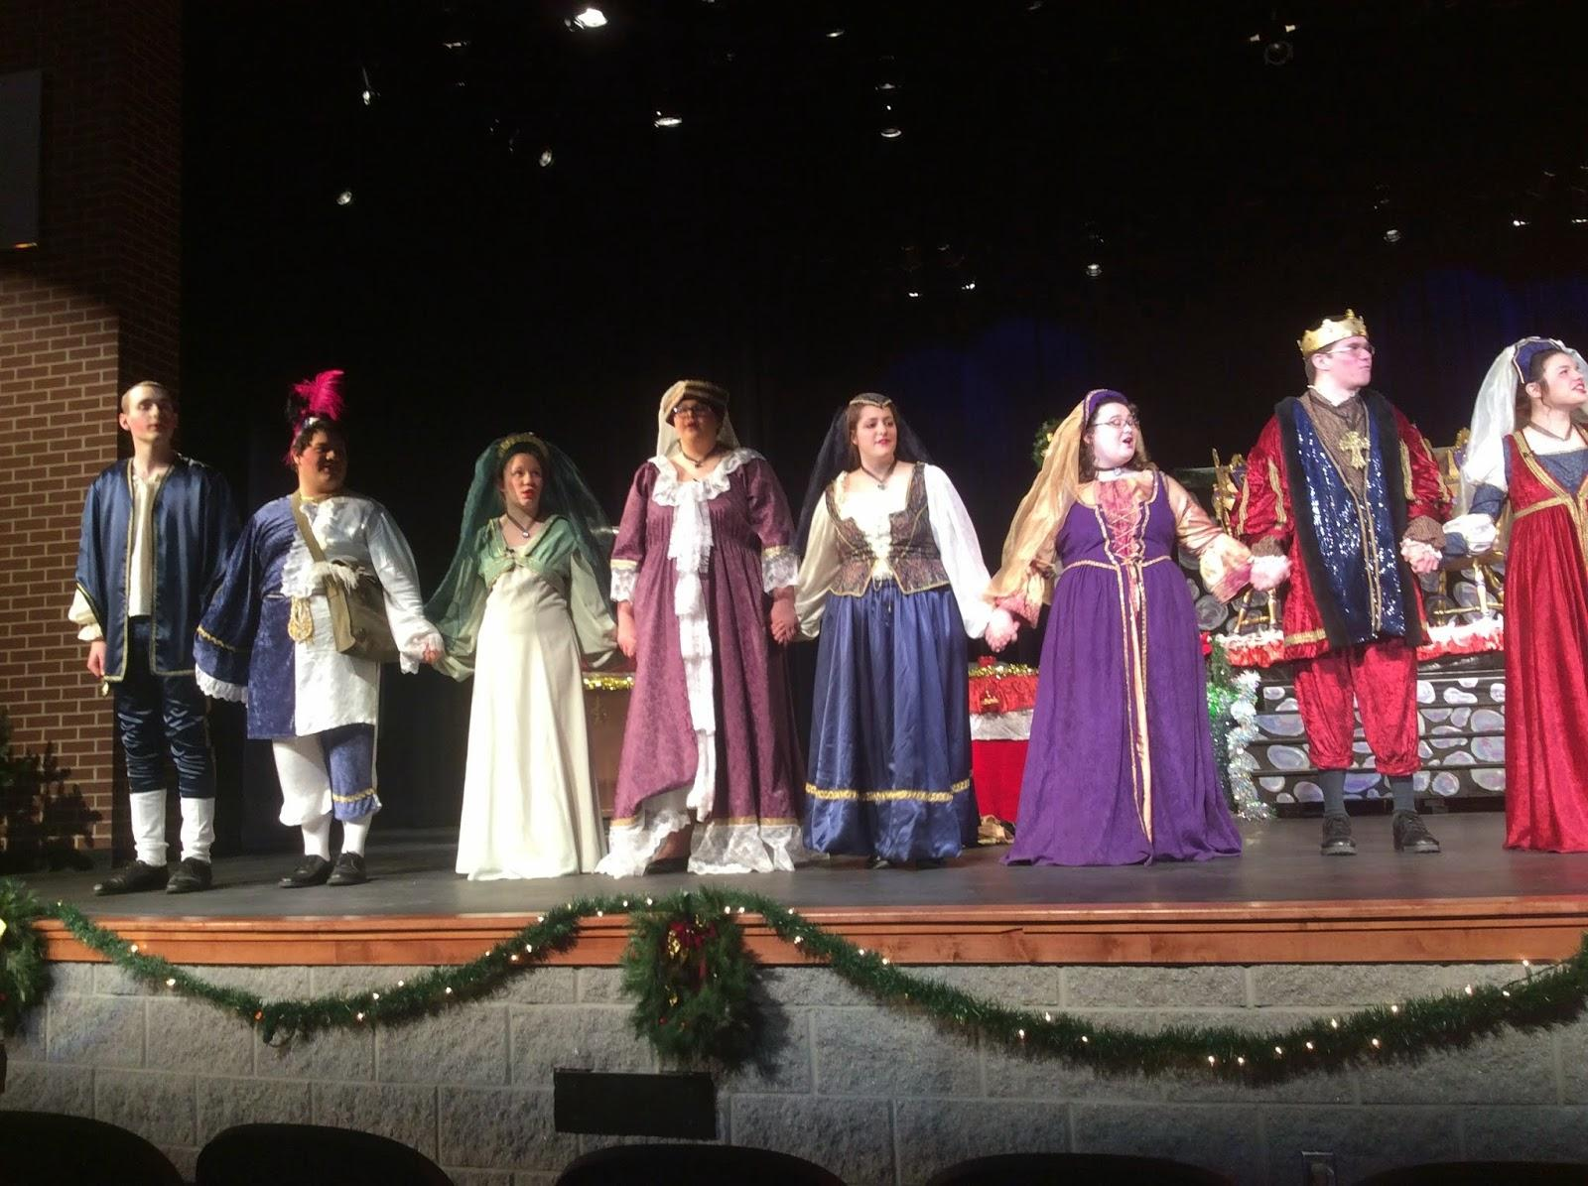

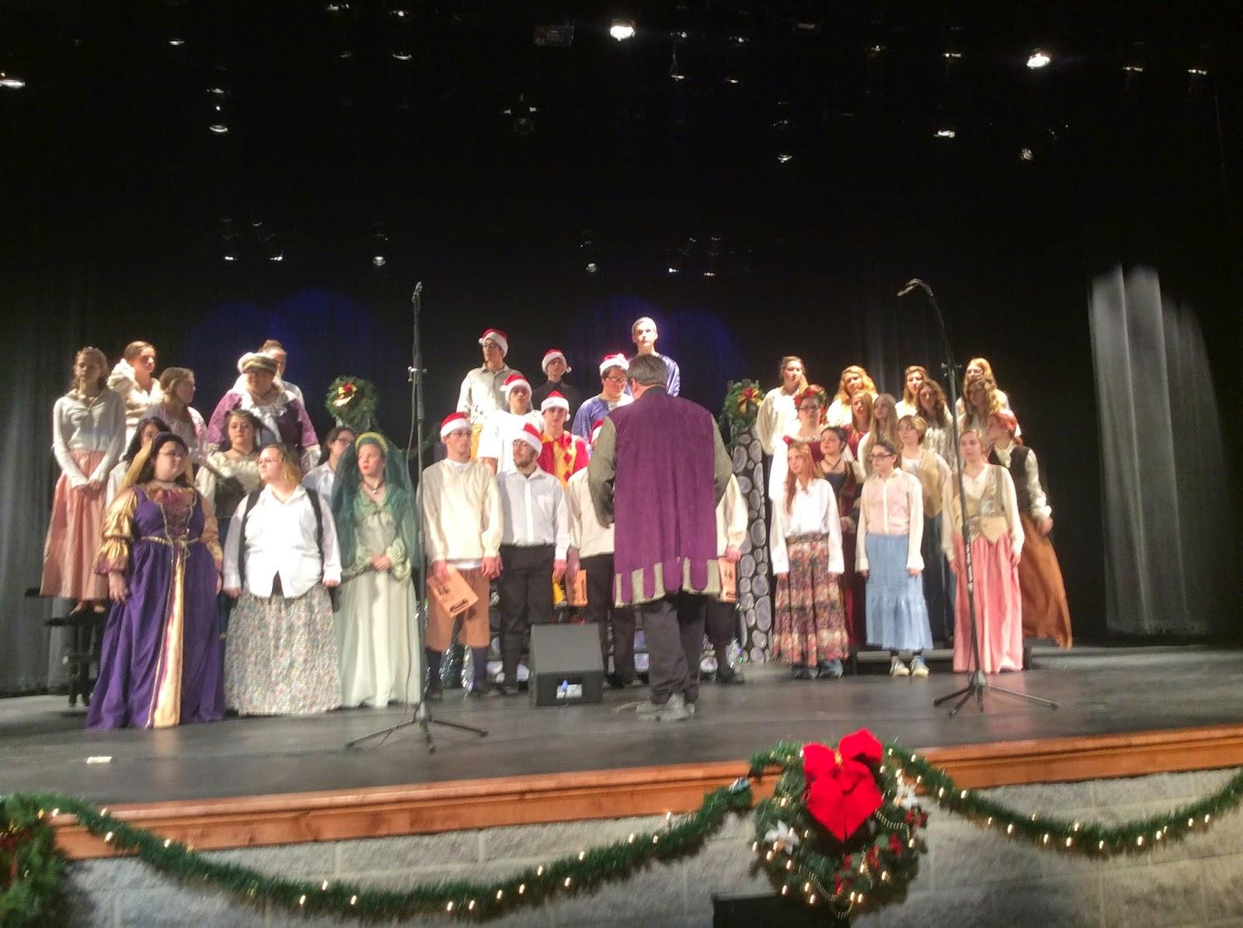

View Online / [Post a comment](https://docs.google.com/document/d/1m7-jbf_mf9qyaO4s5H99fyb4OeGPSffwulsz9asezRw/edit?usp=sharing) / [Suggest Edits](https://quip.com/J2eMAc3tLMZF) / Respond to this story / [Send Email](mailto:cyberlandhq@gmail.com)